

Leadership in Developing and Managing a National Mining Project
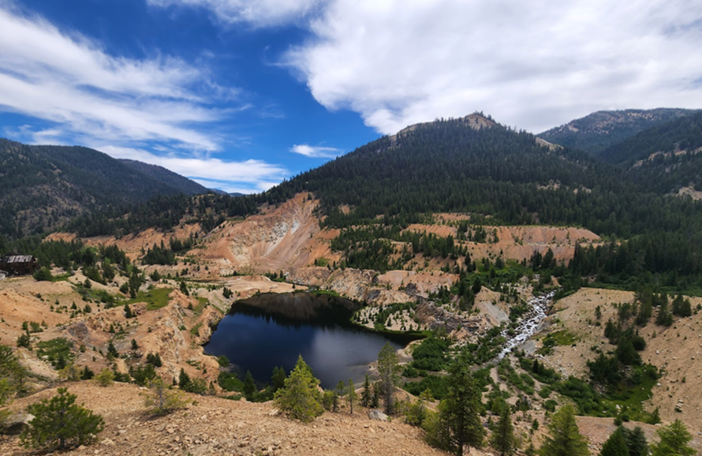

Diploma Thesis

VASILEIOS NASTOS

Supervising Professor: Apostolos Pappas
August 2023
Abstract:

This diploma thesis has to do with a Greek, geological company, that develops a project with the extraction of raw materials and critical metals in Greece. The extracting metal is Antimony.
The project involves the extraction of Antimony, a critical metal found mostly in Macedonia, and many Aegean islands, such as Chios. Nevertheless, small amounts of that mineral (mineralization) are being found in many places around Greece.
This dissertation presents the tasks, a top manager of this specific company’s project must face, and the problems that may occur throughout the entire process.
Specifically, it presents what “Antimony” is and what’s the use in society, for this specific company, to proceed with extraction.
A Gannt chart is provided, to show the timeline of the project, the activities (steps) must be done throughout the entire process, in a detailed and explainable way.
Also, possible problems may occur during the entire process. Types of leadership are provided, to show which style should be adapted in each situation, for a manager to adapt and solve the problem.
Apart from leadership style, management issues are explained, giving emphasis especially to the motivation of the company’s employees and the human resources management, to keep up the proper operation of the entire project.
The project will be very helpful, not only as a short guide of project management by its top managers but also for Greece, to show its natural deposits and their possible use, to boost the economy and recruit people who specialize in this area of science.

Acknowledgements:
I would like to thank my supervising professor Mr. Apostolos Pappas, for the excellent cooperation and help that he provided me.
Also, I would like to thank my parents for all the psychological support and help they have always given me.
Finally, I would like to thank Mr. Makis Fiteoglou, for the excellent guidance and cooperation, throughout the entire duration of studies, in IST College/ESDES-UCLy.

Chapters:
Chapter 1:
Introduction…………………………………………….....page 5

Chapter 2:
2.1 Antimony………………... ……………………….…pages 6-7
2.2 The use of Antimony in our daily lives…………page 8
2.3 The difference between Deposit and Mineralization………. ……………………………………………………..……….page 9
2.4 Places of Antimony in Greece…………………....page…….10

Chapter 3:
3.1 Possible future project and its timeline………...pages 11-27
3.2 Dealing with Leadership problems……………...pages 28-38
3.3 Dealing with Management issues……….…….…page 39
- 3.3.1 Management………………………………..pages 39-43
- 3.3.2 Motivation…………………………………...pages 44-46
- 3.3.3 Human Resources………………………....pages 47-48

Chapter 4:
Epilogue………………….……………………………….page 49

Chapter 5:
Sources……………………………...………………..…..pages 50-55

Chapter 1:
Introduction:
A Greek, geology company, is making a project about the extraction of a specific metal in Greece.
The project the company wants to make has to do with the extraction of Antimony, a critical metal that is being found mostly in Macedonia, and many Aegean islands, not only in the form of “mineralization”, but also in the form of “deposit”, too.
This dissertation presents the tasks, a top manager of this specific company’s project must face, and the problems that may occur throughout the entire process.
Specifically, it presents what “Antimony” is and what’s used in the society. A Gannt chart is provided, to show the timeline of the project, the activities must be done throughout the entire process, in a detailed way.
Types of leadership are provided, to show which style should be adapted in each situation, as well as management issues are explained, to keep up the proper operation of the entire project.

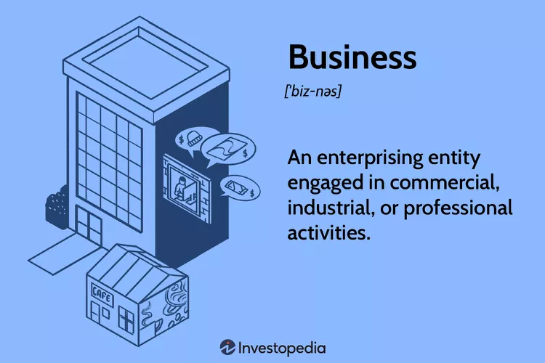
Image 1: Business definition -https://www.investopedia.com/thmb/_RkbFoPwakzeSHMkkn5Y6kSbsJQ=/750x0/filters:no_upscale():max_bytes(150000):strip_icc():format(webp)/business-9536b19e48b54a638b8fd2a8aee60d25.jpg

Chapter 2:
2.1 Antimony:
Antimony is part of the “Nitrogen group elements”. Nitrogen group elements are all the chemical elements that constitute Group 15 (Va) of the Periodic table.¹
Antimony, with “Sb” as its chemical symbol, is a metallic element that belongs to the nitrogen group elements.
Antimony is a lustrous silvery-bluish white solid element, that has a flaky texture and is very brittle. It has a melting point of 630.5^{ο}C and a boiling point of 1,380ºC. It occurs chiefly as the gray sulfide mineral stibnite (Sb₂S₃).
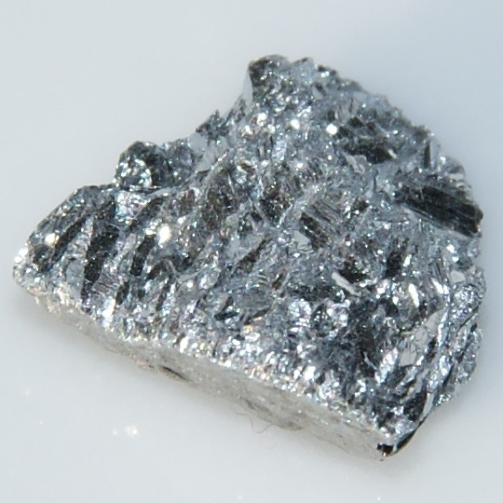
Image 2: Antimony- https://upload.wikimedia.org/wikipedia/commons/5/5c/Antimony-4.jpg
History:
From ancient times, people were familiar with Antimony, both as a metal and in its sulfide form. Fragments of a Chaldean vase, that is made of antimony, it is dated to approximately 4000 B.C.
1. R. Thomas Sanderson
Stibnite was also used in ancient Egypt, as eye makeup. Pliny the Elder, wrote seven different medicinal remedies, using stibnite (antimony sulfide), which he called “stimi” or “stibi” (stibium), during the first century A.C.
Early writings of Dioscorides, mention metallic antimony. They are dating from about the same time. Records of the 15th century, show the use of the substance in alloys for plenty of mirrors and bells.
In the 17th century A.C., a book was published, summarizing all the available knowledge of antimony and its compounds at the time, that had been written by “Basil Valentine”, a Benedictine monk of the 15th century.
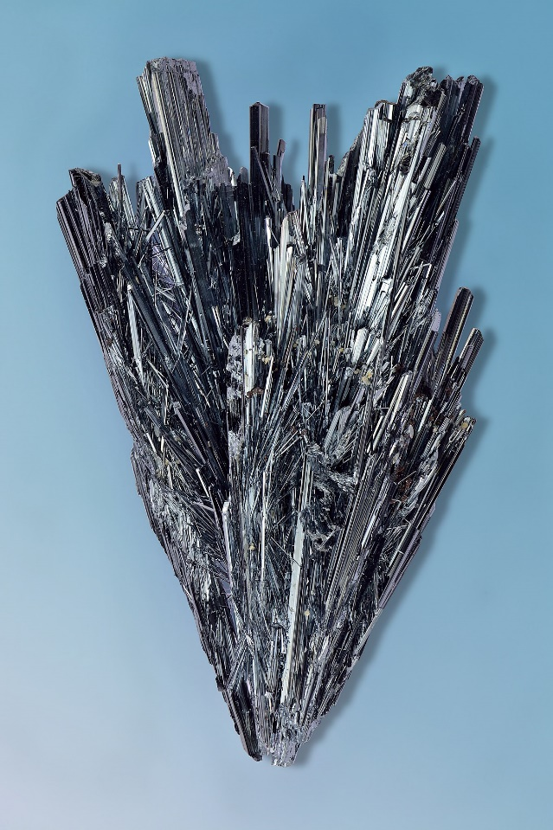
Image 3: Stibnite - https://upload.wikimedia.org/wikipedia/commons/thumb/e/e8/Stibnite_-_Herja_mine%2C_Maramures%2C_Romania.jpg/1200px-Stibnite_-_Herja_mine%2C_Maramures%2C_Romania.jpg

2.2 The use of Antimony in our daily lives:
When scrap iron is heated to a molten state, high-grade or enriched stibnite interacts with it immediately to release antimony metal. The metal can also be obtained by reducing stibnite with carbon after being converted to the oxide. Stibnite can be concentrated from ores using sodium sulfide solutions as leaching agents. Antimony is created by the electrolysis of these solutions. The raw antimony, known as regulus, is further purified before being molded into cakes.
This antimony is used in metallurgy to make alloys, accounting for about half of its utilization. Some antimony alloys are especially valuable as castings and type metal because they expand as they solidify (a rare property that they share with water), forcing the metal to fit the tiny crevices of casting molds.
Furthermore, the inclusion of antimony in type metal, which also contains lead and trace amounts of tin, strengthens the hardness of the type, and gives it a crisp definition. Antimony adds strength and hardness to other metals, notably lead, with which it forms alloys used in vehicle storage battery plates, cable covers, bullets, and chemical equipment such as pipelines and tanks. There are also the “Babbitt metals”, which are antifriction alloys made of antimony, tin, and lead, utilized as parts of machine bearings. Antimony, when combined with tin, produces alloys such as “britannia metal” and pewter, which are used to make utensils.
Additionally, antimony is a component of solder. To create the intermetallic compounds indium, aluminum, and gallium antimonide for diodes and infrared detectors, highly pure antimony is utilized in semiconductor technology.
Paints, plastics, textiles, and rubber frequently employ antimony compounds (particularly trioxide) as flame retardants. Several additional antimony compounds are employed as paint pigments and are used in the textile industry to help in the binding of certain colors to fabrics.²

2.The Editors of Encyclopaedia Britannica, July 12, 2023
2.3 The difference between Deposit and Mineralization:
For a mineral or a rock, to be mined, there must be a profit. Even if there is a metal with high value, like gold, the whole process of extraction, which includes mining, transferring, processing, etc., must be profitable, otherwise, there is no point in extracting that metal, even if its gold.
This is the difference between a mineral or a rock concentration to be named “mineralization” or “deposit”.
Deposit: is the concentration of mineral raw material which, under current economic and technological conditions, can be exploited.
Mineralization: is the concentration of mineral raw material which does not justify its exploitation for any reason whatsoever.
The mineral raw material refers to ores and minerals of economic interest that have been identified through a program of exploration and sampling, considering various factors such as technical, environmental, etc.³
In the “mineralization” term, the reasons that justify why a mineral raw material concentration does not justify its exploitation, are many, like the small quantity of that mineral concentration or the very deep depth that it’s located.
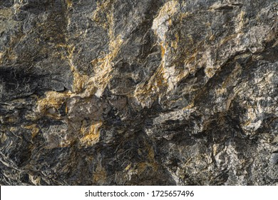
Image 4: Gold antimony ore texture close up contains stock- https://www.shutterstock.com/el/image-photo/gold-antimony-ore-texture-close-contains-1725657496
3. Σκαρπέλης Ν., 2002
2.4 Places of Antimony in Greece:
The two areas in Greece with the highest concentrations of antimony in the form of the mineral “antimonite” (Sb₂S₃) are Kroousia, at Kilkis, north of the town of Lachanas, and Keramos, on the island of Chios. Keramos is a village, which is in the northern part of Chios Island. Lachanas is a town, located in the southeast of the prefecture of “Kilkis”, which is part of “Macedonia”.
In the past, Lachanas' limited quartz vein mining, resulted in the production of 2,700t (ton) of high-grade ore. It should be mentioned that tungsten [(Fe, Mn)WO₄] has been discovered in some parts of the antimony deposit. The strategic metal "tungsten" is extracted using this substance.
There is also a deposit of very high-quality antimonite ore, nearby Keramos Chios, that has been mined and processed via metallurgy on occasion.
A French company conducted the most extensive, though selective, mining of the deposit's rich sections and in-situ metallurgical processing of the ore, for the manufacture of antimony oxide (Sb₂O₃) in this location, in the period of 1880 and 1890.
The mines were closed until 1950. Then, a differential flotation technique attempted to enrich them was launched (Bodossaki business, Marshall Plan). Following the production of 500t of metal concentrate in 1952, operations were again halted, this time due to a fall in the ore's price.
Keramos was one of the most important villages in the Municipality of "Amani" in the middle of the 1960s due to antimony deposits and widespread mining of this material. About 15 exploitation galleries, as well as the cottages of the quarries' staff, are still surviving today.⁴
Of course, plenty of other deposits especially mineralizations, exist in many areas of Greece, but those two are till today, the most important ones, in terms of deposits.

4. Tzeferis P., October 21, 2017
Chapter 3:
3.1 Possible future project and its timeline:
A top manager must form a schedule (a timeline) of all major operations that shall take place, to accomplish any kind of project. The bigger the project, the more important the company is, so the more detailed the schedule must be, in terms of planning and organization.
Of course, the duration of time always plays a significant role. A plan that has a duration of a few months, is more likely to stay tightly on schedule, than a project that has a duration of a few years.
Nevertheless, the bigger the project, the longer the duration of it. So, with good planning and guidance, throughout that period, the forecasting will be more accurate and the whole project will go according to the plan, as much as possible.
The entire project will be based on the following Gannt Chart. This chart shows the major activities that are going to take place. Those activities are 12. The duration of the entire project is expected to be 12 years, from the very beginning to the end.
The Gannt Chart shows those activities simplified and summed. The need for an Analysis based on that chart is mandatory, due to the size of the entire project, the duration, the variety of people who will work, and many more.
Analysis of the Gannt Chart:
The Gannt Chart is about the evaluation of the Antimony concentration as “deposit”, costs and profit assessment, authorization and binding, recruitment and training of personnel, extraction of Antimony, transfer and storage, processing, and sales, and of course the maintenance of the mine, throughout the entire process.
Activity 1- Evaluation of a potential deposit:
As the first step in this entire operation, the top manager shall form a group of scientists, to help him/her evaluate the potential deposit.

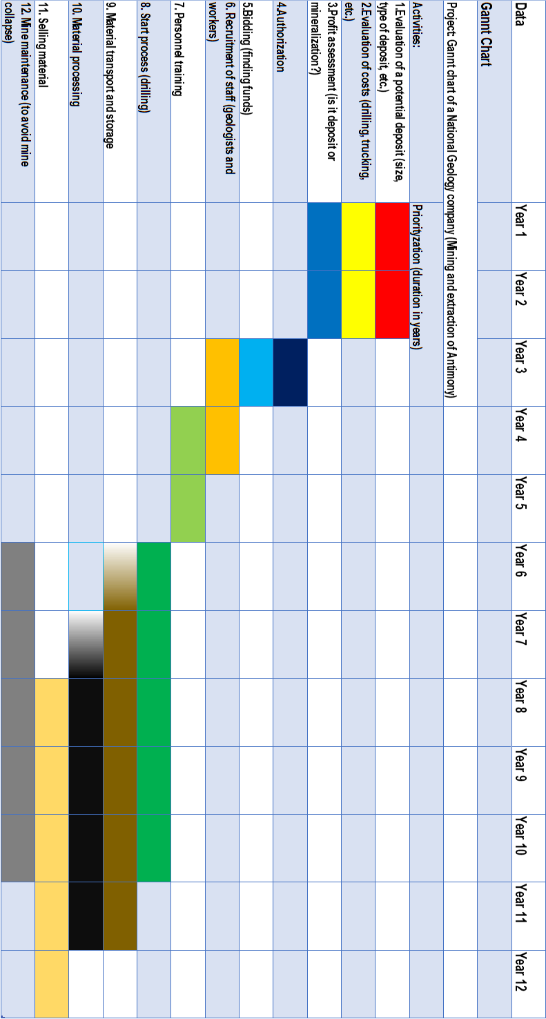
Graph 1: Gannt Chart of the entire Mining Project. Vasilis Nastos
The antimony “concentration” must have a profit, to be called a “deposit”.
Characteristics that will show positive signs for the antimony “concentration” to be named “deposit” and not “mineralization” are plenty. Some of these are:
- Size
- Type of deposit (vein deposits, carlin deposits, etc.)
- Location (near the surface, underground, etc.)
- Political environment and stability of a country (democracy, dictatorship, war, etc.) and many more.
Explanation:
- Size:
When it comes to size, in simple words, the bigger the concentration is, the better the changes are, to justify its exploitation and be a deposit and not a mineralization.
- Type of deposit:
There are several types of mineral deposits. Also, in the specific case of “Antimony”, plenty of types of deposits of this mineral exist, too.
The word “Antimony” comes from the combination of the two Greek words “anti” and “monos”, which means “not alone”, because Antimony by nature, is rarely found alone, in its pure form. As was said before, the most common combination of Antimony (Sb) comes with sulfur (S), forming the “antimony sulfide”, which is well known as “stibnite” (Sb₂S₃).
Antimony can be combined with other chemical elements, such as lead (Pb) and sulfur, forming the mineral “jamesonite” (Pb₂Sb₂S₅), copper (Cu) and sulfur, forming the “tetrahedrite”, etc.
Most antimony deposits have formed from hydrothermal solutions at shallow depths and epithermal solutions (low temperatures). Both are in volcanic areas, where hydrothermal fluids, enriched with plenty of metals, climb up the nearby rocks(volcanic area), due to pressure difference (the closer to the ground they go, the lower the pressure it gets). After some point, they deposit the ore in places, which later, after large concentration, the rocks that have inside them this ore in large quantities, are named “deposits”. Those deposits are called “hydrothermal origin deposits”.
The following are some common forms of antimony deposits.
- Volcanogenic massive sulfide deposits (VMS)
- Vein deposits (stockworks)
- Carlin deposits
- And more⁵
In terms of “Volcanogenic massive sulfide” (VMS) deposits their formation to hydrothermal fluids, that deposit minerals in volcanic rocks.
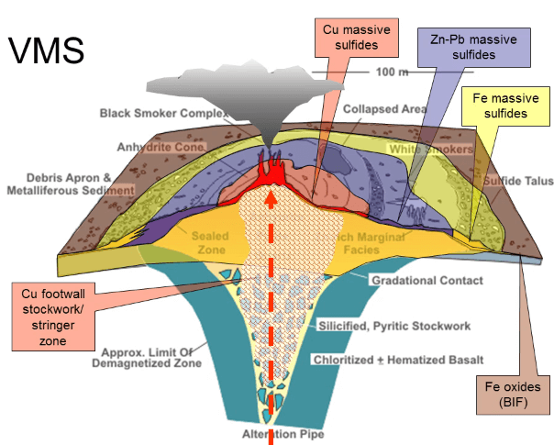
Image 5: Volcanogenic Massive Sulfide (VMS) Deposits - https://i0.wp.com/geologyscience.com/wp-content/uploads/2023/02/Volcanogenic-Massive-Sulphide-Mineralization.png?w=604&ssl=1
In terms of Vein deposits, are generated by hydrothermal fluids that deposit minerals in cracks or fissures in rocks.⁶
In terms of carlin-type (gold) deposits, are sediment-hosted disseminated gold deposits. These deposits have invisible gold (typically in microscopic and/or dissolved form) in arsenopyrite and pyrite which has arsenic enrichment. The Carlin-type deposits show enrichment in the elements of gold, antimony, arsenic, mercury, barium, and thallium.⁷
5. New Nouveau Bruswick
6. Mahmut M., April 23, 2023
7. Wikipedia
- Location:
The following are the primary methods used for extracting minerals from the ground:
- Underground mining
- Surface mining (open pit)
- Placer mining
The location and form of the deposit, the strength of the rock, the ore grade, mining expenses, and the current market price of the commodity are all variables in deciding which mining method to utilize.
- Higher-grade metallic ores discovered in veins far under the Earth's surface can be extracted economically utilizing subterranean technologies, which are often more expensive. Underground mining is also common for large tabular-shaped ore deposits or ore bodies that are more than 300m below the surface.

The rock is drilled and blasted before being brought to the surface by a truck, belt conveyor, or elevator. When the material reaches the surface, it is transported to a mill to separate the ore from the waste rock.

- Lower-grade metal ores located near the surface can be extracted economically, using surface mining technologies, which are often less expensive than underground processes. Many industrial minerals are mined in that way because the ores are often low in value and were deposited at or near the Earth's surface. Hard rock must be drilled and blasted in a surface mine, while some minerals are soft enough to mine without blasting.

- Placer mining is a technique for extracting precious minerals from sediments in modern river channels, beach sands, or historic stream deposits.⁸

8. USGS science for a changing world.
Since most of antimony deposits have formed from hydrothermal solutions at shallow depths and epithermal solutions (low temperatures), in the case of antimony, placer mining cannot be used as a technique.
- Political environment and stability of a country:
A metal concentration can be named as “deposit”, based only on geological factors. Nevertheless, a deposit can exist but there are some conditions, under which it cannot be exploited. One of those conditions is the political environment of a country.
If, for example, there is an ongoing war in a country, the exploitation of a deposit cannot take place. The company cannot move its equipment to that place, nor hire employees to risk their lives working in such an environment, due to war.
Every investigation for mineral deposits begins with the collecting and analysis of existing data, about the geological, mining, and metallogenic backgrounds. Geological maps are always useful because they show possibly occurring deposits to expert ones (for instance, terrestrial volcanic centers with advanced hydrothermal alteration).
Following that, comes the geological exploration step. In mineral exploration, the standard procedure is to evaluate data in two dimensions, using GIS (maps and cross-sections in Geographic Information Systems) and to select targets empirically.
Different metal and mineral deposits need different procedures, but a basic pattern may be outlined with three further stages, the reconnaissance exploration (like satellite pictures), the detailed follow-up exploration (such as contouring sites and anomalies), and of course, the evaluation.
Geochemical exploration will also be undertaken. Geochemical exploration methods are based on the finding that the majority of deposits are surrounded by zones (halos), that differ chemically from the ordinary host rocks. Geochemical data, graphic, and statistical processing, aid in defining places that may suggest minerals (they are referred to as "geochemical anomalies").
Also, geophysical exploration shall take place in mine evaluation. Geophysical exploration methods are the varied physical properties of ore and gangue minerals, fluids, and rocks (Ellis & Singer 2007, Keary et al. 2002). There are plenty of geophysical methods, that help the identification of the minerals under the ground, like magnetometry and electric current methods.
The next stage is trenching and drilling. potential orebodies that are indicated by geological, geochemical, and geophysical exploration methods must be examined by physical exposures. In most cases, this is done by drilling, but trenching through the overburden may reveal valuable information. There are plenty of drilling techniques such as diamond core drilling and Sonic drilling.
After that, in terms of the development and valuation of mineral deposits, it is the geological mapping and sampling, the ore reserve estimation and determination of grade (mineral, or ore reserves), and valuation of mineral deposits.
Finally, is the relationship between mining and the environment. In the case of a mine, Environmental Impact Assessments (EIA) shall be carried out and approved by the authorities when operations are licensed. Mining may disturb many things, such as local society, natural flora and fauna (biosphere), soil and regolith (pedosphere), and more.⁹
After all those stages, the evaluation of a deposit has taken place and the project shall continue to the next activity, which is the evaluation of costs.
Activity 2- Evaluation of costs:
A cost-benefit analysis calculates and analyzes the entire benefits and expenses of a project to the citizens of a certain community. A CBA (“Cost-Benefit Analysis”) does this, by listing all groups in the defined community affected by the project, assessing all impacts in comparison to a counterfactual scenario, valuing the effects on welfare in monetary terms, aggregating these benefits and costs, and estimating the “Net Present Value” to the stated community.
Economic, environmental, and social effects are all possible. The ultimate goal of CBA, however, is to estimate net welfare impacts.
Second-round effects are described as the consequences of expenditure, connected with first-round income increases.
9. Walter L., 2011
A CBA doesn’t often incorporate these implications. Nevertheless, if expenses are spent at one geographical level (such as the state) and benefits accrue at a different level (such as locally), second-round effects may be significant for a report on local consequences.
In terms of estimating the costs and benefits of the project, the first thing needed to be done is the “Cost from Project” or “Direct Net Benefit”.
The type of direct value of the mining project, or VMP is as follows.
VMP = GMR + RV – (OCL + CI + OC + EMEC + RE) (1),
where “GMR” is known as the gross mining revenue, “RV” is the residual value of capital assets and land, “OCL” is the opportunity cost of the land, in foregone uses, “CI” is the capital investment, “OC” is the operating costs, “EME” is the environmental mitigation expenses and of course, “RE” is the rehabilitation expenses.
Following that, comes the "Net Public Infrastructure Cost," which is the cost of any linked public spending (such as drainage and roads) that isn’t included in the mining company's expenses.
Another component is "Valuing Social and Environmental Impacts," which includes possible social and environmental implications, like air quality, water quality, noise, carbon emissions, biodiversity impacts (flora and fauna), and more.
Other potential "First-Round Economic Impacts", include economic surpluses of mining project suppliers of plant, equipment, and materials, mining worker surpluses, losses of rival mining operation’s economic surpluses, and more.
There are also more issues to consider when calculating mining expenses. These are the community of interest (such as defining the boundaries of a local area), valuing the environment (like carbon emissions), first and second-round effects, market modeling (market modeling approach will depend on the scope of the CBA), estimating key mining data (like production operating costs), and risk and uncertainty treatment (like potential damages).
Finally, there are "Special Government Requirements," which may include consequences on employment, some special environmental or social impact, royalties, or local implications.¹⁰
Activity 3- Profit assessment:
After the declaration of the antimony concentration as a “deposit” and the evaluation of the costs of the entire process, the next activity is the profit assessment.
The top manager with their team, shall make a “Cost-Benefit” analysis (it covers the “Net Present Value” analysis, with the addition that “Cost-Benefit” analysis is time-related), comparing the benefits this project is going to have, with the costs of it, annually.
The “Cost-Benefit” analysis is a systematic process that companies use to analyze which decisions are profitable to make and which are costly and shall be abandoned. The cost-benefit analysis sums both the potential rewards, and the total costs of the decision that is about to be made. He/she sums the rewards that are expected from an action or situation and then subtracts the total costs, that are associated with taking that decision.¹¹
In case of benefits are bigger than the costs, the project shall continue. In case of benefits are lower than costs, the project shall lower the costs too and raise them in another, future year.
At the beginning of the project, capital shall be gathered, by stakeholders. That capital shall be used wisely at the beginning because there are not going to be any profits, for at least 8 years since the start of this project, according to the Gannt chart (the activity of “selling material”, which means “sales”, starts at the 8th year of the project).
Of course, in case benefits are lower than costs, after a specific year and till the end of the project (12th year), then the project shall be terminated permanently.
Nevertheless, a “Net Present Value” analysis (NPV), will inform the company and its stakeholders when they are going to take their money back, too. So, the analysts can make both “Cost-Benefit” and “Net Present Value” analyses, to evaluate the potential profit and to determine the future of this project.

10. Abelson P.
11. Hayes A., March 28, 2023
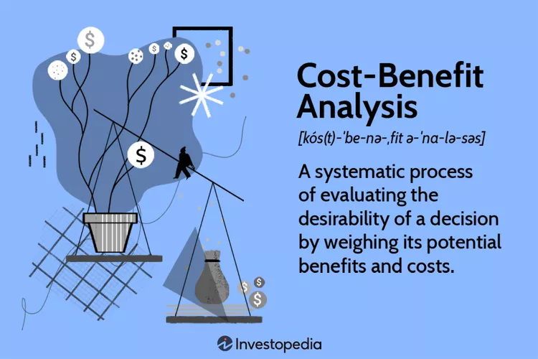
Image 6: Cost-Benefit Analysis definition - https://www.investopedia.com/thmb/YX8Ggrjy6O_p9mTSdHcXqBcxRP8=/750x0/filters:no_upscale():max_bytes(150000):strip_icc():format(webp)/Cost-benefitanalysis-3be1b4befc724d8ca1e69760344ece2f.jpg
Activity 4- Authorization:
The hierarchy of laws in a mining project is three, the acts, the regulations and codes, and the authorizations. Every country has different laws, but that type of hierarchy is always enforced in a mining project.
The Mines Act, Water Sustainability Act, and Environmental Management Act are at the top of the hierarchy. An act establishes high-level standards and includes rules that are generally relevant to the subject matter at hand. Acts also grant the authority to adopt codes, rules, and authorizations.
Regulations and codes are secondary laws, enacted in response to an “Act”. A regulation provides more information than an act, which provides the underlying policy and structure.
Proclamations and codes of practice are two examples of subordinate legislation. For instance, the Health, Safety, and Reclamation Code for Mines in British Columbia (HSRC) has the effect of regulation and is authorized by the Mines Act.
Authorizations (like licenses, certificates, and permits,) allow conduct that would otherwise be prohibited under the law. For example, under the Mines Act, it is illegal to work in, on, or near a mine, unless a permit is in place. The authorization specifies the operational parameters or criteria for the regulated activity.¹²
These three stages are mandatory to ensure the safety of the employees and the proper operation of the entire project.
Activity 5- Bidding:
When everything is ready, in terms of authorization, the finding of capital and stakeholders is essential, because no project in existence can start without an investment.
Even if the process is extremely profitable from the beginning, the whole implementation of the plan needs funds to become a reality.
Especially, in the mining project, the earnings will be significant but in a long-term plan, which means in the distant future. Bidding on that kind of project is not only a major aspect, but involves a lot of capital, too.
The stakeholders, to invest in the project, shall be informed in detail, of the timeline of the project, informing them when they are going to take back their investment in this project, when profits will start, as well as their possible growth rate.
Since the project involves multi-year forecasting about their investment, a form of uncertainty is bound to exist.
It is difficult to effectively manage ore supply via "pit-to-port operations" (from the mining pit, through the plant, to the port where it is loaded onto a ship). It involves overseeing separate teams from the mining operation, plant operations, loading haulage, rail, port operations, marketing, and shipping.
The majority of these teams are guided by key performance indicators (KPIs), that focus on the group's performance, which is not so often aligned with the overall efficiency of the pit-to-port operation.
For example, the goal of avoiding rehandling costs at the run of mine (ROM), may have an impact on ultimate product quality when loaded aboard a ship.
Production forecasting is an important technique for optimizing mining operations through data-driven decision-making. The projection is based on a supply chain model or model of the process.
12. British Columbia Ministry of Energy, Mines and Low Carbon Innovation, January 2023
This model is used to simulate the future utilizing inputs, such as mine production, and scheduled downtime. Many parameters can be changed between simulation runs, to assess the effects of feed uncertainty and unforeseen outages.
As an example, SIMEC Iron Ore Mining Division, located north of Whyalla, South Australia, began the shift of their "pit to port" operations from a pull to a push model, via planning and the use of a production forecasting model.
In the example of SIMEC, the manufacturing prediction helped the marketing team to get insight into the timeliness and quality of the product to be sent. The model was then employed by the mining and operations teams, for assessing the impact of various plant feed schedules. As a result, the push model enabled the operation to avoid the sacrifices associated with chasing shipment grades, resulting in a reduction in fines and maximizing value per cargo loaded.
The production prediction based on the pit-to-port operations model, provides an environment in which to simulate the performance of the operations based on a certain configuration.
Metrics such as net present value (NPV) or adherence to shipment timing and grade schedule, might be used to quantify success. The prediction helps with both planning and identifying chances for process improvement. This model-based environment serves as the foundation for a data-driven decision-making process.
Finally, the pit-to-port model enabled SIMEC to assess the impact of various efforts and guide their decision-making process. The concept also included a framework for communication and collaboration among the many teams, involved in pit-to-port operations.¹³ So, this kind of model, would make forecasting as plausible as possible.
Activity 6- Recruitment of staff:
The recruitment of staff is about personnel management, which is described extensively in Chapter 3.3.3 Human Resources.

13. Mathworks, 2022
Activity 7- Personnel training:
Mining necessitates a lot of physically demanding labor, as well as technical expertise. Miners must be aware of safety regulations, as well as be able to operate and maintain equipment and carry out their duties by industry standards.
Because mining work is hands-on, on-the-job training is required, in which a person learns work-related procedures by seeing and executing job activities. Nevertheless, training on safety laws and regulations, as well as researching work procedures and the construction and functioning of equipment, don’t necessitate one's presence at work. Employees may learn online, thanks to contemporary technologies.
Mobile learning is one viable method for educating mine workers to see all of this. This may be accomplished in two ways. The first and essential requirement is an authoring tool. This is software that enables companies to develop online courses.
Another method is a learning management system (LMS). This is an online training management platform. The firm can upload courses, generated using the authoring tool, as well as training manuals, and other resources, that are considered to be valuable to the company's employees.¹⁴
Activity 8- Start process (drilling):
Drills serve a variety of mining purposes, from supplying geologists with soil samples for research to aiding the extraction of valuable minerals that would otherwise face difficulty in access.
The number of drilling methods grows as the mining sector progresses and new digging opportunities become available. There are drilling methods for any mining objective, whether it is for exploration, land clearance, production, or geotechnical goals.
Drilling methods, such as “auger drilling” (the simplest form of drilling), “reverse circulation drilling, “rotary air blasting” are some of the most common ones.
New types of drill rigs have arisen to satisfy the needs of mining firms as mining operations have gotten more complex over time.
14. African Mining Market, April 26, 2022
Nowadays, many mining drills use diverse capabilities to fulfill various types of mining activities while being both manually and remotely handled. These rigs come in many forms and sizes, and they may work in both small and big quarries.
Some examples of drill rigs are the “surface top hammer drill rigs”, the “development drill rigs, the “surface down-the-hole drill rigs” and more.¹⁵
Activity 9- Material transport and storage:
Conveyor belts and vertical conveyors, heavy-duty blades, buckets, crushers, mills, reclaimers, forklifts, warehousing equipment, and material handling fleet management are just a few of the materials handling and storage systems and components designed for the mining sector.¹⁶
In terms of storage, whole firms exist to assist mines in overcoming their storage problems. A mine's demands frequently require the necessity to keep a large volume of material in a limited amount of area. Shelving with drawers and open shelving, aid in the storage of many things, according to their depth, height, and width.
Since a mining firm is responsible for maintaining and fixing everything that breaks in the mine, it must have the necessary tools, as well as a functioning and durable workstation, like a multi-purpose workstation and a maintenance workstation.
In terms of maintenance and repair, toolboxes play a significant role. Because they are movable, they may be used to repair equipment that is too large to move or simply fixed in place, allowing you to keep all of your tools in one spot.
There are also many more items, such as a shelf unit for staff apparel, a rack for lifting equipment, a rack for radio batteries, and others, that may aid in the proper storage of mining equipment as well as the effective and quick maintenance and repair of everything.¹⁷
15. CR Powered by Epiroc
16. Mining Technology
17. Rousseau High-Quality, Safe and Heavy-Duty Products

Activity 10- Material processing:
Mineral processing is a type of extractive metallurgy, in which varying minerals from ore, are separated and concentrated into a marketable product. Mineral dressing is another term for mineral processing.
Mineral processing is carried out at the mine site and is a highly mechanical process, overseen by a central control room.
A mine's profitability is determined by how much concentrate of the desired mineral can be recovered from the ore. As a result, mineral processing is designed to produce as much mineral concentrate as possible before goods hit the market.
Metals (like aluminum, gold, copper, antimony), rocks (like coal, limestone, marble), and industrial mineral ore (like diamond, garnet, zircon) are extracted by mineral processing.
Mineral processing is a critical stage in transforming ore into a product that can be sold and utilized in daily life.
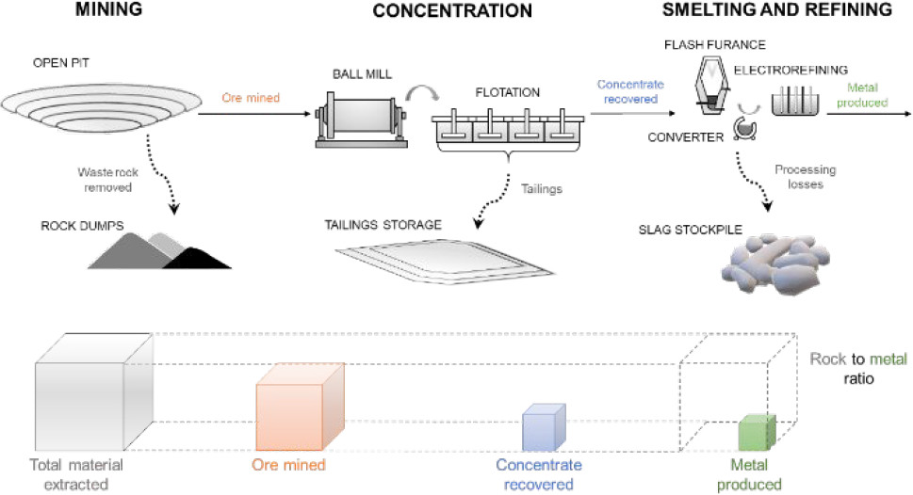
Image 7: Rock-to-Metal Ratio: A Foundational Metric for Understanding Mine Wastes-Mineral Processing, from pit to final product - https://pubs.acs.org/cms/10.1021/acs.est.1c07875/asset/images/medium/es1c07875_0007.gif
The four stages of mineral processing are crushing and grinding (reduction of material’s size), sizing and classification (separating ore by screens), concentration (breaking down the material until the appropriate crude material is obtained) and finally dewatering (water removal from mineral).
For each stage of processing, there is the equivalent equipment, which is corresponding, cone crushers and jaw crushers, bar screens and fine screens, cleaners and scavengers, rotary dryers, and dewatering screens and of course, much more.¹⁸
Activity 11- Selling material:
Once the building is completed and everything has been inspected, to make sure that it performs according to its design specifications, the share price should rise as the company's worth is fully appreciated.
Every exploration business aims towards production, which simply means extracting material from the earth and selling it. At this point, investors should be paying great attention to production rates (how much is being produced, how quickly, and how much the profit might be).
An investor can get information about a company's output for that quarter, in its quarterly report.
The share price is typically divided into three phases. First is "Exploration I", which corresponds to the exploration and definition phases of the company lifecycle (explore, find, and value a deposit). Secondly, is "Exploration II", which corresponds to the feasibility studies phases of the company lifecycle (find stakeholders and build the mine), and last, is "Producers", which begins when a resource company begins construction and eventually begins producing its commodity (start extracting and shipping).¹⁹
Activity 12- Mine maintenance:
Finally, is the maintenance of the mine, throughout the entire process of the project (to be exact, according to the Gannt chart, from the 6th, when drilling starts, up to the 11th year of the project, when transportation and storage ends).

18. FLYABILITY
19. The Mining Company Life Cycle Explained, March 22, 2022
The maintenance of the mine plays a significant role in the security of the company’s personnel. Potential industrial accidents may occur, if the maintenance is either false or doesn’t occur regularly and on schedule.
Another factor that can be avoided, is the partial collapse of the mine, during the night. In that case, no victims will occur, which is the most important factor of all, but the damage will have a major impact on the project. The bigger the damage, the longer it will take to get fixed, and the bigger the delay will be.
If the delay has a duration of many months, it will negatively affect the timeline of the whole project, leading possibly to the withdrawal of the company's funds and the termination of the entire process.
Mine maintenance may seem like a secondary activity, but it plays a vital role in terms of the sustainability of the entire project.

3.2 Dealing with Leadership problems:
Leadership is a dynamic process that varies depending on the events and changes that take place inside an organization and that affects how subordinates and leaders behave by those changes and situations.
Because of the diversity in scholars' opinions on this subject, definitions of leadership vary.
" Leadership is the activity of influencing people to strive willingly for mutual objectives.", says Terry.
According to Koontz and O'Donnell, "Leadership is the process of influencing people so that they will strive willingly towards the achievement of group goals".
The definition of leadership provided by Stogdill is "The process (act) of influencing the activities of an organized group in its efforts toward goal setting and goal achievement". Due to the different perspectives of scholars, there exist additional meanings about “leadership”.
By definition, it follows that management and leadership are not the same thing. “Leadership” often holds that, depending on the situation, it may be necessary to alter people's attitudes and behaviors, including how a company runs. Leadership frequently refers to creative approaches taken to enhance a company's operational circumstances.
On the other side, “management” refers to the upkeep and support of the business's operations and activities. So, it plays a role in implementation.²⁰
Management is a whole subject, that is going to be analyzed in the next chapter (chapter 3.3).
Leadership is playing a significant role, not only in terms of project development and management but everywhere.
There are six leadership styles, that can be applied not only in a project or a company, but everywhere, in every field that includes leadership. Those are not the only ones.
20. Ζαβλανός Μ., 2002
- Directive ("Do what I tell you.")
- Visionary ("Here's where we're going and why.")
- Affiliative (Leading via relationship.)
- Participative ("Let's decide together/communicate.")
- Pacesetting ("Run fast and keep up!")
- Coaching (Long-term development of others.)
Top-performing leaders have demonstrated proficiency in four or more of the six types, but only 20% of leaders reach this level. Unfortunately, according to the research, most leaders are overly reliant on one style, which restricts their effectiveness as a leader.
To create a high-performance culture, every leader should develop as many abilities as possible. The more styles you master, the more circumstances you can effectively manage.
The table that follows, compares the mining industry with a cross-sector group and demonstrates that the directive and pace-setting styles are most frequently employed in the mining industry, as they get the maximum score (55 and 53, correspondingly).
Unfortunately, an over-dependence on these two leadership philosophies is closely associated with low employee engagement and high turnover. It should come as no surprise that the methods of "Run fast, keep up" and/or "Do what I tell you", don't exactly inspire great levels of drive-in individuals, leading employees to have less critical thinking, low self-esteem or they just follow orders without caring for the business or enjoy their work.
It is only natural for a leader (or perhaps a whole sector) to attempt to justify excessively prescriptive and pace-setting leadership styles.
The research indicates that many leaders in the mining industry might benefit from being more visionary (explain the purpose), more participatory (asking rather than telling), and more coaching (feedback) than they already are, because their employees will know why they are doing their job, feel better and participating more, by expressing their opinion and start caring about their job and the company they are working to.
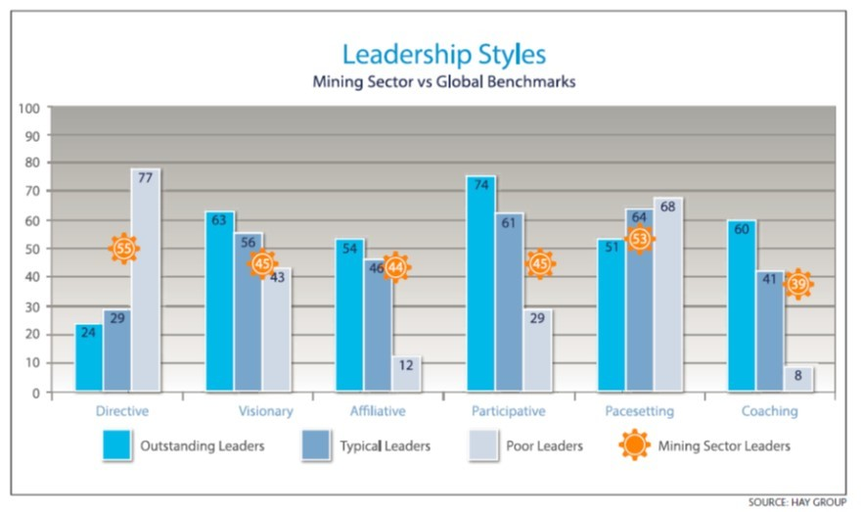
Graph 2: Leadership styles- Mining sector versus global benchmarks-https://media.licdn.com/dms/image/C5612AQGc5p6NHTjSbA/article-inline_image-shrink_1000_1488/0/1520253520503?e=1694649600&v=beta&t=tB_LnGrrCnRiSLgONmIAAK_o0yK70etEUnqKH5krVK4
A formal feedback tool that is filled out by both the leader and their direct reports can help leaders better understand how they combine the six leadership styles. The base for self-awareness, development planning, coaching, and progress as a leader to grasp the entire toolkit of styles is provided by this feedback.
In conclusion, high-performing leaders learn to apply the appropriate tools for the job and master four or more different leadership philosophies. Additionally, they achieve better levels of engagement, retention, and success.²¹
A leader will always validate everybody’s opinion, encourage them to express themselves, be motivated, and encourage his/her employees and of course whenever needed, to be in charge of the situation and the entire operation.
Having critical thought and changing leadership styles according to every current situation, distinguishes a common leader from a true, capable leader.

21. Pederson B., May 14, 2015
In addition, there are more leadership types, such as transactional leadership, charismatic leadership, transformational leadership, autocratic leadership, bureaucratic leadership, democratic leadership, and Laissez-Faire leadership.
These types of leadership differ in approach, style, and behaviors leaders exhibit. Additionally, these styles vary regarding decision-making authority, motivation techniques, team involvement, and overall leadership approach. Each style has its strengths and weaknesses, depending on the situation.
A “transactional leader” can use social exchanges to influence others, to achieve their goals. On the one hand, these leaders establish clear expectations and performance standards, ensuring that others understand what is expected of them. They use rewards and recognition to motivate their team members, fostering productivity and performance.
On the other hand, this type of leadership primarily focuses on maintaining existing processes and achieving established goals. Needless to say, this can potentially stifle innovation and creativity within the team. The transactional approach of this leadership style can also lead to a lack of personal and professional growth opportunities for team members.
A “charismatic leader” can motivate others and inspire them, by being energetic and just themselves (being charismatic). On the one hand, these leaders can inspire and motivate others through their energy and charisma. They also create an optimistic work atmosphere, fostering high morale and engagement.
On the other hand, their persuasive abilities can be utilized for self-serving purposes without considering the best interests of the organization or the team. The focus on motivating and inspiring may overshadow the practical aspects of execution and implementation. Nevertheless, a charismatic leader is an excellent type of leader.
A “transformational leader” transforms others to achieve greater success and growth. On the one side, these leaders encourage creativity, challenge the status quo, and foster a culture of continuous improvement and growth. Additionally, they create a supportive and empowering work environment.
On the other side, the high expectations of transformational leaders and the drive for excellence can sometimes lead to increased pressure and workload for employees. In addition to this, those types of leaders, driven by the pursuit of organizational goals, may overlook the developmental needs of individual team members.
“An autocratic leader” can make decisions and give orders, without the need to get to know his/her employees, their opinions, and their characters, but just to get the job done. On the one side, rapid and immediate response in times of crisis is made possible by autocratic rule. Also, this leadership approach minimizes uncertainty by giving precise guidance and instructions.
On the other side though, team members may feel disengaged or undervalued when their input is limited under an autocratic leadership style. Additionally, the lack of feedback from others can prevent the development of original concepts and a variety of viewpoints.
A “bureaucratic leader” relies on the rules and the procedures that are already being established in a company, for example, to guide their leadership approach. On the positive side, the goal of bureaucratic leadership is to reduce risks by adhering to established procedures and standards. They establish explicit guidelines and procedures, that advance organizational effectiveness, uniformity, and order.
On the negative, these leaders tend to be rigid and inflexible in their approach because they stress adhering to established rules and processes over flexibility. Additionally, they frequently exert strict control over obligations and duties, limiting individual autonomy and decision-making power.
A “democratic leader” involves others everywhere, encourages collaboration, participates, and asks his/her existing staff for the decision-making process. The advantages of this type of leader are that they encourage a sense of ownership and commitment in the team by involving team members in decision-making. Also, this leadership style promotes a sense of worth and voice among workers. In essence, this increases motivation and job happiness.
The disadvantages of this type of leader are that democratic leadership can cause arguments and consensus-building, which can slow things down. It can also result in conflicts amongst team members, necessitating competent conflict resolution.

Image 8: Advantages and disadvantages of democratic leadership style - https://www.google.gr/url?sa=i&url=https%3A%2F%2Ftheculturalsociety.com%2Fadvantages-and-disadvantages-of-democratic-leadership-style%2F&psig=AOvVaw1uLvlqzISm1C6j4wrdb7eu&ust=1689871734888000&source=images&cd=vfe&opi=89978449&ved=0CA4QjRxqFwoTCKi3rf2cm4ADFQAAAAAdAAAAABAn
A “Laissez-Faire leader”, provides freedom and autonomy to his/her staff, allowing them to make and take their own decisions. On the positive side, Laissez-faire leaders give people freedom and autonomy, encouraging initiative and creativity. Additionally, with this style of leadership, workers are urged to accept responsibility for their work, which boosts self-motivation.
On the negative side, employees may feel lost or unsettled under this style of leadership because there is often a lack of direction. Laissez-faire leadership's emphasis on freedom and autonomy can result in a lack of accountability and a decline in overall productivity.
As was said before, the best type of leadership (the best leader), is the one that combines as many types of leadership as possible, according to a certain situation.
For a leader, some of the most important skills that one must have, are critical thinking (choosing the correct type of leadership in every situation), flexibility and open-mindedness (adapting to change) the problem solving (facing the problems and finding a solution), and the empathy (emotional quotient or emotional intelligence, for being in someone else’s shoes and see the world from a different ankle).
Critical thinking involves the leader, determining the best leadership style to use within their organization. There are six steps that can help a leader choose his/her leadership style.
- Step one: Understand himself/herself deeply. Managers should invest some time in understanding their strengths and weaknesses.
- Step two: Define his/her core values. Managers should find out what leadership styles may align with their core values.
- Step three: Try different leadership styles. Managers should test themselves to find out how they react to each style.
- Step four: Ask for feedback. Managers should get a second opinion from others, to see how they see their manager’s leadership style.
- Step five: Learn from other leaders. Managers should look for leaders they respect and admire.
- Step six: Find a mentor. Managers should find a mentor, to help them by providing his/her guidance and insights.²²
The flexibility and open-mindedness are connected. An open-minded leader must be flexible. He/she has to be prepared to make accommodations, bend when required, and act in the organization's and its employees' best interests.
When someone attempting to lead as an inventive manager, logical thinking is furthermore necessary. He/she can make sensible decisions by considering a range of viewpoints. As this form of management frequently shocks folks with conventional attitudes, courage is also required. The choices someone makes when he/she is open-minded frequently include change and consequently, danger.

22. Joshi K., August 10, 2022
The advantage of open-minded managers is that they never stop learning. A leader, respecting his/her employees’ creativity and opinions will empower them. One benefit is that even when the company has challenges during challenging economic times, people are frequently motivated by the leader’s approach and follow willingly and loyally.
The disadvantage of open-minded managers is the lack of respect that may occasionally occur, from people who don't understand this type of management style. Sometimes a staff member will see the manager's open-mindedness as a weakness, a lack of confidence, or a waffle. This could result in a bad work atmosphere. Managers who use this strategy can explain to their staff its viability, advantages, and reasonability.²³
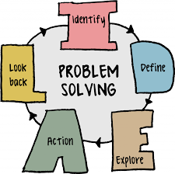
Graph 3: Problem-solving - https://uta.pressbooks.pub/app/uploads/sites/56/2019/07/ps-ideal.png
In business, problem-solving is the process of locating and addressing difficulties or problems that develop. While carrying out daily operations. There are always issues that need to be resolved in any organization, from production problems to client complaints.
Effective problem-solving entails taking a methodical approach to locating the issue, investigating it, and coming up with and putting into practice a solution.

23. Mooney L.
Business problem-solving success calls for a trifecta of analytical prowess, teamwork, and creativity. To ensure that the solution fully addresses the problem, it is crucial to include significant stakeholders in the process, such as employees, suppliers, and clients. Businesses may increase productivity, boost customer happiness, and accomplish their strategic goals by solving challenges effectively.
An effective leader needs these skills because, with problem-solving, a leader can deal with problems that will occur inside the company, improve efficiency, find with their team innovative solutions, by thinking outside of the box, build trust with their team members, so they will feel confident and safe around such leader, and more. So, being a problem solver as a leader is essential.²⁴
Genuine concern for their team members' emotional well-being, potential difficulties, or even personal interests is demonstrated by empathetic leaders. Empathic leaders can connect with others on a deep level, provide support, comprehend their needs, and create lasting relationships. Empathy enables leaders to connect with their team members and successfully address their needs, by offering encouragement, comfort, and support, through trying moments rather than focusing solely on the business outcomes.
Traits of compassionate leadership:
Promoting a feeling of belonging and purpose within the team. Identifying when team members require additional support or assistance and anticipating their requirements. When team members are speaking, actively listening, and making a conscious effort to be fully present and involved.
Recognizing the backgrounds, experiences, and difficulties that team members have endured while caring about their growth on both a personal and professional level. Establishing a setting where team members may communicate their opinions and ideas without worrying about criticism or retaliation.
Empathy Matters in Leadership:
The following conditions can affect workers at work, according to the World Health Organization (WHO).
24. Soil INSTITUTE of MANAGEMENT, February 21, 2023
- Long, solitary, or rigid hours
- Limited assistance from team members or leaders
- Unsafe working conditions
- Overwhelming workload
- Bad work-life balance
- A work environment that encourages unproductive habits
To provide a safe environment for workers, mental health issues are addressed at work, by empathic leadership. A recent study by Catalyst, a worldwide non-profit organization, which included 899 employees in the U.S.A., shows the value of empathy in the workplace.
Innovation at work is a direct result of empathic leadership. At a percentage of 61% of workers under highly empathic senior leaders and 47% of workers under highly empathic managers reported being innovative.
Empathetic management also increases employee engagement at work. About 76% of workers with highly empathic senior leaders and 67% of workers with highly empathic managers, reported being frequently or always engaged at work.
A percentage of 86% of employees who work for highly empathic senior leaders and 82% of those who work for highly empathic supervisors are more successful at juggling their personal and professional responsibilities. So, empathetic leaders have a positive impact on the work-life of their staff.
Compassionate leadership encourages inclusivity, too. Only 17% of workers under less compassionate senior leaders reported experiencing inclusiveness at work, compared to 50% of those under compassionate senior leaders.
A leader with empathy has a greater understanding of his/her team members, boosts communication and innovation, increases employee engagement, and makes better decisions, because he/she valid his/her employee’s opinions and sees things from a different perspective, leading to a better point of view and understanding of the whole situation in a much better point.²⁵

25. Joshi K., February 28, 2023
In conclusion, according to the previous research, the directive and pace-setting styles are most frequently employed in the mining industry. Unfortunately, these two leadership philosophies are closely associated with low employee engagement and high turnover.
The research indicates that many leaders in the mining industry might benefit from being more coaching, more visionary, and more participatory than they already are because their employees will know why they are doing their jobs, feel better, and participate more. So, develop a more democratic leadership style, rather than an autocratic one.
Nevertheless, the best type of leadership is for someone to apply the appropriate tools for the job and master many different leadership philosophies.
Critical thinking, flexibility and open-mindedness, problem-solving, and empathy, are some of the most important and helpful skills a leader can own, to make him/her stand out as a reliable manager and climb up the hierarchy fast.

3.3 Dealing with Management issues:
3.3.1 Management:
Although Henry Fayol's traditional definition of management is still used today, there is no widely recognized definition of management as an activity. In many aspects, his broad assertion about "management" is still true and only more contemporary writers have adopted it, as is evident in the examples below.
Fayol: “To manage is to forecast and plan to organize, to command, to coordinate and to control.”
Koontz and O’ Donnell: “Managing is an operational process initially best dissected by analyzing the managerial functions… the five essential management functions (are) planning, organizing, staffing, directing and leading, and controlling.”
T. Petters: “Five areas of management constitute the essence of proactive performance in our chaotic world: 1) an obsession with a responsiveness to customers, 2) constant innovation in all areas of the firm, 3) partnership- the wholesale participation of end game sharing with all people connected with the organization, 4) leadership that loves change (instead of fighting it and instills and shares and inspiring vision), and 5) control by means of simple support systems aimed at measuring the right stuff for today's environment.”
The concept of “management” should be separated from that of “administration”. The main focus of the administration is on organizing. Comparatively, management is also concerned with organizing, overseeing, and inspiring people.
Management is not one activity that can be completed on its own. It is rather a description of a range of tasks, performed by individuals, who are designated as "managers" in organizations. These individuals might, for example, have formal accountability for one or more employees' work or be responsible for specialist advisory duties in support of important management activities. The majority of these activities have been categorized as planning, organizing, motivating, and controlling activities.
These classifications define actions that, largely in terms of their inputs, show what managers perform in practice. They apply to both middle and senior management roles, as well as, to supervisory and junior management positions.
There are four steps that can be used, to condense the management activity groups. The four steps are described below.
- Planning: Deciding the organization’s objectives and planning how to achieve them.
- Organizing: Identifying activities and allocating responsibilities for plan implementation. Arranging activities and responsibilities according to a suitable system.
- Motivating: Addressing workers' social and psychological needs, while achieving company objectives.
- Controlling: Monitoring and evaluating activities and offering remedies.
First is “planning”. Making decisions on actions, goals, and outcomes, is a part of planning. It is an action that is carried out while considering the organization's internal and external strengths and disadvantages. Strategic and corporate planning are examples of long-term planning, whereas, setting annual departmental budgets is an example of a short-term planning activity.
Long-term often refers to a time range of five years more or less. Short-term can refer to any time frame between the present and, roughly, one year. In this project, we must have a long-term planning (12 years plan).
Secondly, is “organizing”. It is necessary to carry out the plans. Tasks must be carefully planned out and coordinated, as well as the human and material resources required to complete them. Here, formal communications and other issues in terms of “communication”, are a major concern.
Thirdly, is “motivating”. Managers’ motivational actions are primarily practical in nature, because of require cooperation between their staff, to set and carry out the company’s plans. The motivation will be explained in a detailed way in the next chapter.
Lastly, is “controlling”. Measuring progress and reversing deviations are the main concerns of controlling operations. A manager must set performance standards, compare actual performance to those standards, and take corrective actions as needed.
All managerial operations use control activities as a feedback mechanism.²⁶
Management levels:
The levels of management are the lines that separate various administrative jobs inside an organization. The number of management levels rises in tandem with the growth of the company and its workforce, and vice versa. Various levels of management can define the chain of command within an organization, as well as the amount of power and typically, decision-making influence, attained by all administrative jobs.
Levels of management may be classified into three major types, each of which gives various tasks to managers.
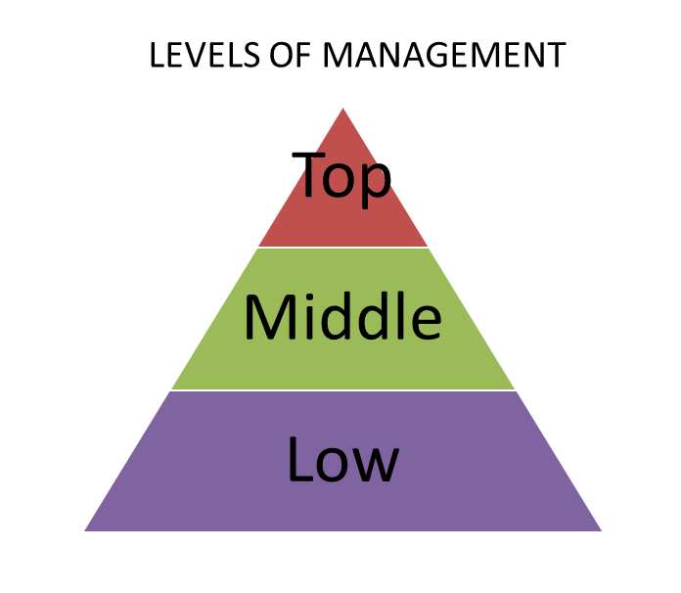
Graph 4: Levels of Management - https://upload.wikimedia.org/wikipedia/commons/d/d9/Levels_of_management.png
- Top level of management, administrative, or managerial.

Is the "Top management." This level of management is comprised of an organization's chief executive or managing director and its board of directors. It is the ultimate source of authority and power since it is in control of a company's aims, procedures, and regulations. Their key objective is strategic planning and execution, for overall business success.

26. Cole, 2004
Top-level management's functions and responsibilities include defining the company enterprise's goals and basic policies, providing the necessary guidelines for the creation of budgets, timetables, and plenty more to a specific department, appointing departmental managers as executives for middle-level management, putting controls in place, across all organizational divisions, and more.

The top management level, comprised of the Board of Directors, is also in charge of interacting with the outside world and is accountable to the shareholders of an organization for the running of the company. Giving overall guidance and encouraging harmony and collaboration.

- Middle or Executive Level of Management.

Is the "Middie Manager". The branch and departmental managers compose this intermediate management level. Because they are directly responsible to senior management for the running of their respective divisions, these professionals devote more time to organizational and directed responsibilities. Smaller companies frequently have only one layer of middle management, but bigger companies may have senior and junior levels.

Middle-level management’s functions and responsibilities, include putting the organization's plans into action by the guidelines and policies, established by the highest management level, creating plans for the organizational divisions they are in charge of, participating in lower-level management's hiring and training processes, explaining, and interpreting top management's policies to lower-level management, and more.

- Lower level of management, supervisory or operative.

Is the "First in Line Manager". This level of management includes foremen, section officers, superintendents, and any other executives that supervise operational workers and are largely responsible for human resources. Simply said, lower-level managers are primarily concerned with the execution and coordination of daily workflow that assures the completion of projects and the delivery of deliverables.

Lowest-level management tasks and responsibilities include distributing responsibilities and jobs among different employees, assisting and training employees in daily tasks, and acting as mediators by explaining higher-level aims and objectives to workers while also expressing difficulties and other worker input to higher levels of management, thanks to intimate connections with staff, and more.²⁷
Career paths for mine geologists are many and wide-ranging. Over time, with success and constantly growing experience, mine geologists can progress to more senior roles, such as “project geologist”, “environmental scientist”, “GIS analyst”, “senior Hydrogeologist” or even executive-level positions, such as “GIS manager” or “senior geologist”.²⁸
The hierarchy of course can go even higher. For example, the “GIS manager” can be promoted to “chief information officer” and from there, to “senior vice president”, reaching out not only to top managers positions but eventually the CEO’s position or even the owner of the company.²⁹

27. SpriggHR, February 12, 2020
28. ZIPPIA THE CAREER EXPERT, June 29, 2023
29. ZIPPIA THE CAREER EXPERT, June 29, 2023
3.3.2 Motivation:
In essence, the goal of human motivation research is to understand what causes and maintains human behavior. A working definition of motivation is that “Motivation” is the term used to describe those processes, both instinctive and rational, by which people seek to satisfy their basic drives, perceived needs, and personal goals, which trigger human behavior.” (Cole, 1995, page 119).
Although most of the early theorists were concerned with the desires and/or demands of people at work, not all theorists concentrated on the process of motivation.³⁰
Maslow’s hierarchy of needs:
Maslow suggested that human wants might be arranged in a hierarchy to better understand what drives people. The demands in this hierarchy vary from more necessities, like food and water, to more abstract ideas, like self-fulfillment. When a lower need is satisfied, the following need up the hierarchy takes center stage, according to Maslow.
According to Maslow, there are five different types of needs: physiological, safety, love, esteem, and self-actualization.
According to this hypothesis, when people believe they have satisfactorily met the previous need, higher needs in the hierarchy start to arise.
Although subsequent research has not entirely endorsed Maslow’s idea, his work has influenced other psychologists and advanced the area of positive psychology.
Here are the five different types of needs, according to Maslow’s hierarchy of needs.
- Physiological:
These speak of fundamental bodily requirements like drinking when you're thirsty or eating when you're hungry. Some of these wants, according to Maslow, involve our efforts to satisfy the body's need for homeostasis, which entails maintaining steady levels in various biological systems (for instance, maintaining a body temperature).
30. Cole, 2004

- Safety:
The demand for a safe environment comes after people's physiological needs have been satisfied. Maslow noted that safety requirements in adults in industrialized countries are more pronounced in emergencies (such as disasters), but this need can also account for why we frequently choose the comfortable or why we take actions like buying insurance and contributing to a savings account.

- Love and belonging:
The next need in the hierarchy, in Maslow's theory, is to feel accepted and loved. This desire encompasses links to friends and family as well as romantic relationships. Our need to feel a part of society is also included.

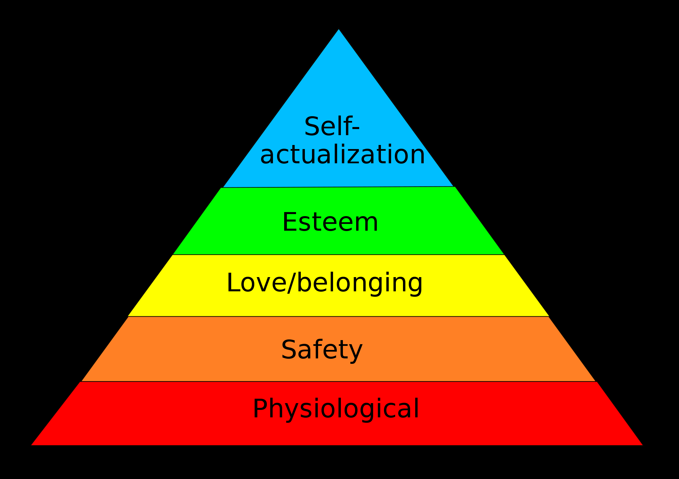
Graph 5: Maslow’s hierarchy of needs -https://www.google.gr/url?sa=i&url=https%3A%2F%2Fcourses.lumenlearning.com%2Fsuny-monroecc-hed110%2Fchapter%2Ftheory%2F&psig=AOvVaw0L8dA33oSfyoCy2p9QnOcL&ust=1689961313418000&source=images&cd=vfe&opi=89978449&ved=0CA4QjRxqFwoTCLjp4dHqnYADFQAAAAAdAAAAABAI

- Esteem:
The urge to feel good about oneself is a component of our esteem needs. Maslow says that esteem requirements include two parts. The first entails having self-assurance and positive self-esteem. The second element is the perception of worth from others. People feel confident and value their contributions and accomplishments when their esteem requirements are addressed.

- Self-Actualization:
When we feel content or like we are living up to our potential, we are said to be self-actualizing. Self-actualization has the distinctive quality that it looks different for everyone. Self-actualization refers to the sensation of carrying out our perceived calling. Maslow asserts that obtaining self-actualization is relatively uncommon.³¹

31. Hopper E., February 24, 2020

3.3.3 Human Resources:
Personnel management, in the sense of human resource management, can’t be imposed on everyone accountable for the work of others. However, the HRM method assumes a wide definition of "personnel management" and tells us nothing about the specific areas of work, where people professionals make a significant contribution to a company.
Personnel management is the specialized function of management, that is responsible for formulating, gaining, and proposing acceptance, for the organization's personnel policies and strategies, advising and guiding the organization's managers on the implementation of personnel policies and strategies, and providing personnel services to organizations to facilitate their recruitment, motivation, and development of sufficient and suitable employees.
Senior personnel managers are in charge of policy development and strategic planning. Senior and middle-level people managers, share advising and counseling duties.
Because of their specialized job, all personnel managers, regardless of seniority, can focus solely on personnel issues (HRM), in contrast to their colleagues in other departments, who can devote a limited amount of their time to HRM.
Personnel rules, like any other business policy, aren’t the exclusive domain of a small number of executives. Such policies must be agreed upon by the whole senior management team and authorized by the Board. Close recruiting and selection, compensation and benefits, training, safety and health, employment legislation, and other key aspects of personnel policy.
The manpower plan, the maintenance of employee motivation through fair and equitable payment systems, the organization's actions about new developments in employment legislation, the development of harmonious and mutually respectful relationships with trade union representatives, and other issues are covered by strategic advice on personnel matters.
Personnel services are a component of "Personnel Management" that is operational or production-oriented. Recruitment services, assessment procedures, employee relations, safety health, and welfare services, and training services are a few examples of personnel services.
In addition to policymaking, personnel services, and strategic planning, most modern personnel departments are expected to have something helpful to say about the consequences of change for the organization's workers. This is known as the "Organization Development function of Personnel" in some companies. This activity is focused on recognizing change from any source and assessing the potential impact of that change on people affairs in the company (such as the introduction of a new technology).
The attitude of the organization's senior management will define the function of staff. Where staff are acknowledged as having a major part to play in the renewal and maturation processes of the organizational system, the "Personnel Manager" will be assigned a crucial position in the organization's corporate growth.
In contrast, if personnel are viewed as a provider of services to other managers, the "Personnel Manager" will be assigned a routine administrative function, that will be supplemented at intervals by "fire-fighting" tasks if a crisis occurs.³²

32. Cole, 2004

Chapter 4:
Epilogue:
This diploma thesis had to do with a geological, Greek company, that developed a project for the extraction of metals in Greece.
The project had to do with the extraction of the metal “Antimony”, a critical metal that is found mostly in Macedonia, and many Aegean islands, such as Chios. Nevertheless, small amounts of that mineral are being found in many places around Greece.
This dissertation presented the tasks, a top manager of this specific company’s project must face, and the problems that may occur throughout the entire process.
Questions like “what the “Antimony” is” and “what’s the use in the society”, have been answered, in this diploma thesis.
A Gannt chart is provided, to show the timeline of the project, in a detailed and explainable way.
Also, possible problems may occur during the entire process. Types of leadership are provided, to show which style should be adapted in each situation, and management issues are explained, giving emphasis, especially to the terms “motivation” and “human resources”.
The project is going to be very helpful, not only as a short guide of project management by its top managers, but also for Greece, to show its natural deposits and their possible use, for boosting the economy and recruiting people who specialize in this area of science.
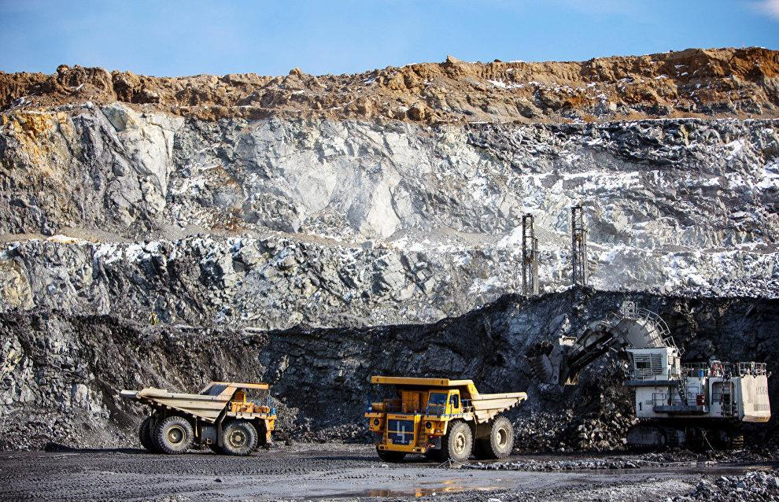
Image 9: Antimony deposit in northern Tajikistan - https://asiaplustj.info/sites/default/files/articles/321722/%D0%B7%D0%B0%D0%BF%D0%B0%D1%81%20%D1%81%D1%83%D1%80%D1%8C%D0%BC%D1%8B1.jpg
Chapter 5:
Sources:
Images:
- Cover logos:
- ESDES- https://www.esdes.fr/wp content/uploads/sites/12/2022/09/2022_logo_esdes_bleu_sans_fond-1739x576.png
- IST College- https://i0.wp.com/mareport2022.e-expo.gr/wp-content/uploads/02-IST.jpg?fit=800%2C800&ssl=1
- Cover image:
Untangling the ASAOC from Perpetua Resources-Idaho Rivers United
https://images.squarespace-cdn.com/content/v1/60a6c34d62a20e102bb26220/1661268078592-DH12X5R91KETJ692YVMG/Screen+Shot+2022-08-22+at+2.57.56+PM.png

- Image 1: Business definition, page 5 -https://www.investopedia.com/thmb/_RkbFoPwakzeSHMkkn5Y6kSbsJQ=/750x0/filters:no_upscale():max_bytes(150000):strip_icc():format(webp)/business-9536b19e48b54a638b8fd2a8aee60d25.jpg
- Image 2: Antimony, page 6 - https://upload.wikimedia.org/wikipedia/commons/5/5c/Antimony-4.jpg
- Image 3: Stibnite, page 7 - https://upload.wikimedia.org/wikipedia/commons/thumb/e/e8/Stibnite_-_Herja_mine%2C_Maramures%2C_Romania.jpg/1200px-Stibnite_-_Herja_mine%2C_Maramures%2C_Romania.jpg
- Image 4: Gold antimony ore texture close up contains stock, page 9 - https://www.shutterstock.com/el/image-photo/gold-antimony-ore-texture-close-contains-1725657496
- Image 5: Volcanogenic Massive Sulfide (VMS) Deposits, page 14-https://i0.wp.com/geologyscience.com/wp-content/uploads/2023/02/Volcanogenic-Massive-Sulphide-Mineralization.png?w=604&ssl=1
- Image 6: Cost-Benefit Analysis definition, page 20 - https://www.investopedia.com/thmb/YX8Ggrjy6O_p9mTSdHcXqBcxRP8=/750x0/filters:no_upscale():max_bytes(150000):strip_icc():format(webp)/Cost-benefitanalysis-3be1b4befc724d8ca1e69760344ece2f.jpg
- Image 7: Rock-to-Metal Ratio: A Foundational Metric for Understanding Mine Wastes-Mineral Processing, from pit to final product, page 25 - https://pubs.acs.org/cms/10.1021/acs.est.1c07875/asset/images/medium/es1c07875_0007.gif
- Image 8: Advantages and disadvantages of democratic leadership style, page 33 - https://www.google.gr/url?sa=i&url=https%3A%2F%2Ftheculturalsociety.com%2Fadvantages-and-disadvantages-of-democratic-leadership-style%2F&psig=AOvVaw1uLvlqzISm1C6j4wrdb7eu&ust=1689871734888000&source=images&cd=vfe&opi=89978449&ved=0CA4QjRxqFwoTCKi3rf2cm4ADFQAAAAAdAAAAABAn
- Image 9: Antimony deposit in northern Tajikistan, page 49 - https://asiaplustj.info/sites/default/files/articles/321722/%D0%B7%D0%B0%D0%BF%D0%B0%D1%81%20%D1%81%D1%83%D1%80%D1%8C%D0%BC%D1%8B1.jpg

Graphs:
- Graph 1: Gannt Chart of the entire Mining Project. Vasilis Nastos, page 12
- Graph 2: Leadership styles- Mining sector versus global benchmarks, page 30 -https://media.licdn.com/dms/image/C5612AQGc5p6NHTjSbA/article-inline_image-shrink_1000_1488/0/1520253520503?e=1694649600&v=beta&t=tB_LnGrrCnRiSLgONmIAAK_o0yK70etEUnqKH5krVK4
- Graph 3: Problem-solving, page 35 - https://uta.pressbooks.pub/app/uploads/sites/56/2019/07/ps-ideal.png
- Graph 4: Levels of Management, page 41 - https://upload.wikimedia.org/wikipedia/commons/d/d9/Levels_of_management.png
- Graph 5: Maslow’s hierarchy of needs, page 45 - https://www.google.gr/url?sa=i&url=https%3A%2F%2Fcourses.lumenlearning.com%2Fsuny-monroecc-hed110%2Fchapter%2Ftheory%2F&psig=AOvVaw0L8dA33oSfyoCy2p9QnOcL&ust=1689961313418000&source=images&cd=vfe&opi=89978449&ved=0CA4QjRxqFwoTCLjp4dHqnYADFQAAAAAdAAAAABAI

References:
Articles and books:
- R. Thomas Sanderson. Britannica. [online] Available at: https://www.britannica.com/science/nitrogen-group-element
- The Editors of Encyclopaedia Britannica, July 12, 2023. Britannica. [online] Last updated: July 12, 2023, Available at: https://www.britannica.com/science/antimony
- Σκαρπέλης Ν., 2002 (Partial book review 2006). “Εισαγωγή στην Κοιτασματολογία”. Athens, page 12.
- Tzeferis P., October 21, 2017. Greek Mineral Wealth. [online] Available at: https://www.oryktosploutos.net/2017/10/sb/
- New Nouveau Brunswick. Antimony, Mineral Commodity Profile No.12. [online] Available at: https://www2.gnb.ca/content/dam/gnb/Departments/en/pdf/Minerals-Minerales/mcp_12-e.pdf
- Mahmut M., April 23, 2023. Mineral Deposits. [online] Available at: https://geologyscience.com/geology-branches/mining-geology/mineral-deposit/ (paragraph “Some common types of mineral deposits”).
- Wikipedia. Carlin-type gold deposit. [online] Available at: https://en.wikipedia.org/wiki/Carlin%E2%80%93type_gold_deposit
- USGS science for a changing world. How do we extract minerals. [online] Available at: https://www.usgs.gov/faqs/how-do-we-extract-minerals
- Walter L. P.,2011, Economic Geology Principles and Practice. [e-book]: WILEY-BLACKWELL. Available at: https://www.geokniga.org/bookfiles/geokniga-economic-geology-principles-and-practice-metals-minerals-coal-and-hydrocarb.pdf - pages of pdf (which are different from the book pages) 457-458, 460, 463, 469-470,473, 475, 478,480-482, 488-489, 491.
- Abelson P. Cost-Benefit Evaluation of Mining Projects. [online] Available at: https://appliedeconomics.com.au/wp-content/uploads/2021/10/2015-cost-benefit-of-mining-projects.pdf
- Hayes A., March 28, 2023. What Is Cost-Benefit Analysis, How Is it Used, What Are its Pros and Cons. [online] Available at:
https://www.investopedia.com/terms/c/cost-benefitanalysis.asp
- British Columbia Ministry of Energy, Mines and Low Carbon Innovation, January 2023 , Major Mines Authorizations Guide. [e-book]: Ministry of Energy, Mines and Low Carbon Innovation. Available at: https://www2.gov.bc.ca/assets/gov/farming-natural-resources-and-industry/mineral-exploration-mining/documents/permitting/mmpo/major_mines_auth_guide.pdf , pages 3 and 4.
- Mathworks, 2022. Production Forecasting for Mining Operations with Simulation.[online] Available at: https://www.mathworks.com/content/dam/mathworks/white-paper/production-forecasting-pit-to-port-whitepaper.pdf
- African Mining Market, April 26,2022. Employee training and upskilling in the mining industry-why it’s a top priority. [online] Last updated: April 26, 2022 Available at: https://africanminingmarket.com/employee-training-and-upskilling-in-the-mining-industry-why-its-a-top-priority/13021/
- CR Powered by Epiroc. Types of Drilling in Mining. [online] Available at: https://crmining.com/mining-drill/
- Mining Technology. Mining material handling equipment and storage solutions for the mining industry. [online] Available at: https://www.mining-technology.com/buyers-guide/mining-material-handling-storage/
- Rousseau High-Quality, Safe and Heavy-Duty Products. Storage System for the Mining Industry. [online] Available at: https://www.commander.ca/wp-content/uploads/2018/02/Mining-Storage-Systems.pdf
- FLYABILITY. What Is Mineral Processing in Mining? [online] Available at: https://www.flyability.com/mineral-processing
- The Mining Company Life Cycle Explained, March 22, 2022. The Mining Company Life Cycle Explained. [online] Available at: https://nextinvestors.com/learn-to-invest/mining/mining-company-life-cycle-explained/
- Ζαβλανός M. Μ., Ph. D, 2002.“Οργανωτική Συμπεριφορά”. Athens: Publications Σταμούλη Α.Ε., pages 245-246.
- Pederson B., May 14, 2015. Leadership Styles In Mining: Helping or Hindering? [online] Available at: https://www.linkedin.com/pulse/leadership-styles-mining-helping-hindering-brent-pederson
- Joshi K., August 10, 2022. Discovering Your Leading Style: A Guide to 8 Types of Leadership. [online] Available at: https://emeritus.org/blog/different-types-of-leadership/
- Mooney L. Open-Minded Management Styles. [online] Available at: https://smallbusiness.chron.com/openminded-management-styles-30804.html
- Soil INSTITUTE of MANAGEMENT, February 21, 2023. WHY PROBLEM-SOLVING SKILLS ARE ESENTIAL FOR LEADERS IN ANY INDUSTRY. [online] Available at: https://www.soil.edu.in/why-problem-solving-skills-are-essential-for-leaders-in-any-industry/
- Joshi K. February 28, 2023. Why is Empathetic Leadership Important in Today’s Workplace? [online] Available at: https://emeritus.org/blog/leadership-empathetic-leadership/
- Cole G.A., 2004. “Management Theory and Practice”. 6th edition. Thomson publications, pages 6, 8-11.
- SpriggHR, February 12, 2020. The 3 Different Levels of Management. [online] Available at: https://sprigghr.com/blog/hr-professionals/3-different-levels-of-management/
- ZIPPIA THE CAREER EXPERT, June 29, 2023. MINE GEOLOGIST OVERVIEW. [online] Available at: https://www.zippia.com/mine-geologist-jobs/
- ZIPPIA THE CAREER EXPERT, June 29, 2023. CHIEF INFORMATION OFFICER OVERVIEW. [online] Available at: https://www.zippia.com/chief-information-officer-jobs/
- Cole G.A., 2004. “Management Theory and Practice”. 6th edition. Thomson publications, page 30.
- Hopper E., February 24, 2020. Maslow’s Hierarchy of Needs Explained. [online] Available at : https://www.thoughtco.com/maslows-hierarchy-of-needs-4582571
- Cole G.A., 2004. “Management Theory and Practice”. 6th edition. Thomson publications, pages 334-336.

